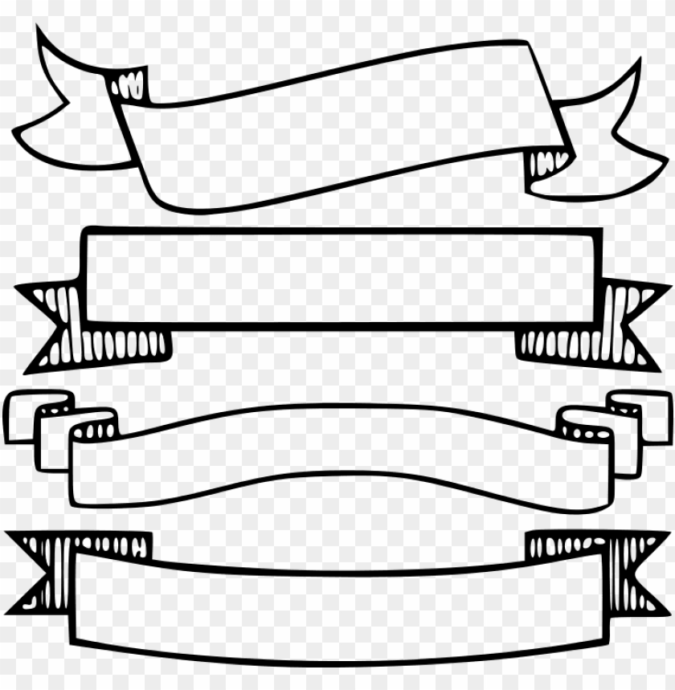

**LEARNING OUTCOME BOOK**

* **UNIT 1**

**Vocabulary:**

* Noun suffixes: -ness, -ity, -ship, -hood.
* Collective nouns.
* Negative prefixes: dis-, mis-

**Grammar:**

* Present progressive - Present simple- Stative verbs
* must, have to, need to, mustn’t, can’t, may, could, might
* should, ought to, had better
* **UNIT 2**

**Vocabulary:**

* Similes
* Compound adjectives
* Words related to traveling

**Grammar:**

* Past simple
* Used to
* Past simple - Past progressive
* Past perfect simple

**SUBJECT LINK:**

* **CHAPTER 1 “INSECTS”**

**Science** *Insects Q & A*

**Science** *Cicadas*

**Social Studies**

*The Butterfly Effect*

**Social Studies**

*Eating Insects.*

* **CHAPTER 2 “Mountains”**

**Science** *How Mountains Are Formed*

**Social Studies** *The Wall of Death*

**Social Studies** *Sherpas*

**Sports** *Mountain Survival Skills*

**ENGLISH THIRD GRADE**

**FIRST TERM**

